TUTORIAL 5

NAME : VED MULEY
CLASS : CE 3
BATCH : C
TOPIC : Hands-On: Chat GPT and Gemini.
____________________________________________________________________________

PROGRAM :

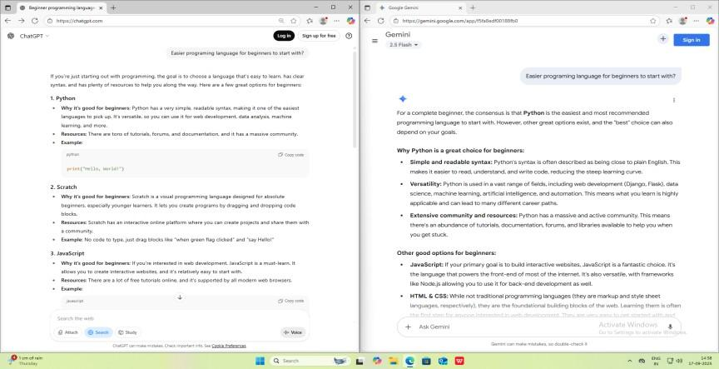

OUTPUT :

PROMPT :

Easier programming language for beginners to start with?

SIMILARITIES :
Both suggested Python as an easier language for beginners which shows that both can analyze data and provide summaries at similar level. Both have real time web search making it easier to give quick responses and insights about questions. Both can answer easy to complex questions and can reply as per our requirement. Both Chabot’s excel at understanding, generating and responding to human language.
DIFFERENCES :
CHATGPT suggested the easy programming language “SCRATCH” in its top 3 list while GEMINI suggested moderate languages such as Java and HTML & CSS. CHATGPT gave actual code examples while GEMINI provided detailed information with no examples. This shows that GEMINI emphasized more on providing theoretical information while CHATGPT had a practical approach in explanation.
CONCLUSION :

Both had almost common results. GEMINI gave much more detailed information about all the languages such as its versatility, script style, resources to learn etc. while CHATGPT gave the common information available across the internet. I felt that GEMINI provided much more detailed information than CHATGPT. GEMINI suggested most used languages such as Java, HTML & CSS while CHATGPT included easiest languages as commanded. CHATGPT had much clearly cited sources and conversational writing along with flow while Gemini is good at data analysis and shows results similar to Google results being a part of Google service ecosystem.

